**Practical 21: Take any string from user but string should contain more than 3 words. Write a program to display string according to ascending order of total number of characters in each word.**

**Example: str "Super Hero is mad" Output: is mad Hero Super**

**Code:**

|  |
| --- |
| //Q21.cs file  using System;  public class Q21  {  public void Asen(string str)  {  int count = 0;  bool isNewWord = true;  for (int i = 0; i < str.Length; i++)  {  if (str[i] == ' ')  {  isNewWord = true;  }  else if (isNewWord)  {  count++;  isNewWord = false;  }  }  if (count <= 3)  {  Console.WriteLine("Input should contain more than 3 words.");  return;  }  string[] arrStr = new string[count];  int index = 0;  string word = "";  for (int i = 0; i < str.Length; i++)  {  if (str[i] == ' ')  {  if (word != "")  {  arrStr[index] = word;  index++;  word = "";  }  }  else  {  word += str[i];  }  }  if (word != "")  {  arrStr[index] = word;  }  for (int i = 0; i < arrStr.Length - 1; i++)  {  for (int j = i + 1; j < arrStr.Length; j++)  {  if (arrStr[i].Length > arrStr[j].Length)  {  // Swap words  string temp = arrStr[i];  arrStr[i] = arrStr[j];  arrStr[j] = temp;  }  }  }  for (int i = 0; i < arrStr.Length; i++)  {  Console.Write(arrStr[i] + " ");  }  }  }  // Program.cs file  using System ;  public class Program{  public static void Main(string[] args)  {  Q21 q21 = new Q21();  q21.Asen("This is CSharp Program");  }  } |

**Output:**

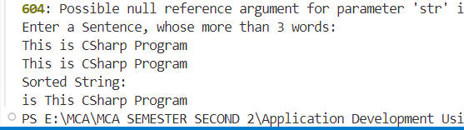

**Program 22: Write a program to calculate the HCF of two, three and four integer numbers using function overloading concept.**

**Code:**

|  |
| --- |
| //Q22.cs file  using System;  public class Q22  {  public int CalculateHCF(int a, int b)  {  while (a != b)  {  if (a > b)  a = a - b;  else  b = b - a;  }  return a;  }  public int CalculateHCF(int a, int b, int c)  {  int tempHCF = CalculateHCF(a, b);  return CalculateHCF(tempHCF, c);  }  public int CalculateHCF(int a, int b, int c, int d)  {  int tempHCF = CalculateHCF(a, b, c);  return CalculateHCF(tempHCF, d);  }  }  // Program.cs file  using System ;  public class Program{  public static void Main()  {  Q22 obj = new Q22();  Console.Write("Enter two numbers: ");  int a = Convert.ToInt32(Console.ReadLine());  int b = Convert.ToInt32(Console.ReadLine());  Console.WriteLine("HCF of " + a + " and " + b + " is: " + obj.CalculateHCF(a, b));  Console.Write("\nEnter three numbers: ");  int x = Convert.ToInt32(Console.ReadLine());  int y = Convert.ToInt32(Console.ReadLine());  int z = Convert.ToInt32(Console.ReadLine());  Console.WriteLine("HCF of " + x + ", " + y + " and " + z + " is: " + obj.CalculateHCF(x, y, z));  Console.Write("\nEnter four numbers: ");  int p = Convert.ToInt32(Console.ReadLine());  int q = Convert.ToInt32(Console.ReadLine());  int r = Convert.ToInt32(Console.ReadLine());  int s = Convert.ToInt32(Console.ReadLine());  Console.WriteLine("HCF of " + p + ", " + q + ", " + r + " and " + s + " is: " + obj.CalculateHCF(p, q, r, s));  }  } |

**Output:**

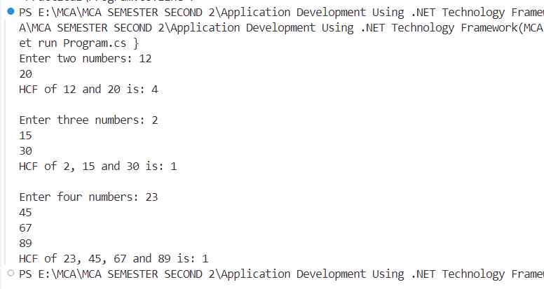

**Program 23: Write a program to rotate a matrix 90 degree clockwise.**

**Code:**

|  |
| --- |
| // Program.cs file  using System;  public class Program  {  public static void Main()  {  Console.Write("Enter matrix size (n x n): ");  int n = Convert.ToInt32(Console.ReadLine());  int[,] matrix = new int[n, n];  Console.WriteLine("Enter matrix elements:");  for (int i = 0; i < n; i++)  {  for (int j = 0; j < n; j++)  {  matrix[i, j] = Convert.ToInt32(Console.ReadLine());  }  }  int[,] rotatedMatrix = new int[n, n];  for (int i = 0; i < n; i++)  {  for (int j = 0; j < n; j++)  {  rotatedMatrix[j, n - 1 - i] = matrix[i, j];  }  }  Console.WriteLine("Rotated Matrix (90° Clockwise):");  for (int i = 0; i < n; i++)  {  for (int j = 0; j < n; j++)  {  Console.Write(rotatedMatrix[i, j] + " ");  }  Console.WriteLine();  }  }  } |

**Output:**

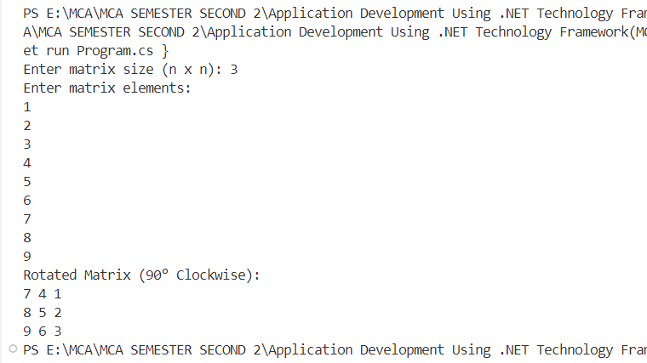

**Program 24: Take any string from user. Write a program to find vowels in a string and store them in an array. If the occurrence of any vowel is more than 2 then don't store it in an array.**

**Code:**

|  |
| --- |
| using System;  public class Program  {  public static void Main()  {  Console.Write("Enter a string: ");  string input = Console.ReadLine();    char[] vowels = new char[input.Length];  int[] count = new int[5];  int index = 0;  for (int i = 0; i < input.Length; i++)  {  char ch = input[i];  if (ch == 'a' || ch == 'A') count[0]++;  if (ch == 'e' || ch == 'E') count[1]++;  if (ch == 'i' || ch == 'I') count[2]++;  if (ch == 'o' || ch == 'O') count[3]++;  if (ch == 'u' || ch == 'U') count[4]++;  if ((ch == 'a' || ch == 'A') && count[0] <= 2) vowels[index++] = ch;  if ((ch == 'e' || ch == 'E') && count[1] <= 2) vowels[index++] = ch;  if ((ch == 'i' || ch == 'I') && count[2] <= 2) vowels[index++] = ch;  if ((ch == 'o' || ch == 'O') && count[3] <= 2) vowels[index++] = ch;  if ((ch == 'u' || ch == 'U') && count[4] <= 2) vowels[index++] = ch;  }  Console.Write("Filtered vowels: ");  for (int i = 0; i < index; i++)  {  Console.Write(vowels[i] + " ");  }  }  } |

**Output:**

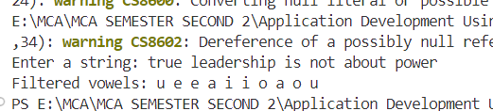

**Program 25: Write a program to split an array in such a way that all prime numbers store separates together and non-prime numbers store separately. If sum of first array is greater than second array then display array as it is otherwise display all elements square. Don't use the inbuilt function.**

**Code:**

|  |
| --- |
| using System;  public class Program  {  public static void Main()  {  Console.Write("Enter the size of array: ");  int n = Convert.ToInt32(Console.ReadLine());  int[] arr = new int[n];  int[] primeArr = new int[n];  int[] nonPrimeArr = new int[n];  int primeIndex = 0, nonPrimeIndex = 0, sumPrime = 0, sumNonPrime = 0;  Console.WriteLine("Enter array elements:");  for (int i = 0; i < n; i++)  {  arr[i] = Convert.ToInt32(Console.ReadLine());  }  for (int i = 0; i < n; i++)  {  if (IsPrime(arr[i]))  {  primeArr[primeIndex++] = arr[i];  sumPrime += arr[i];  }  else  {  nonPrimeArr[nonPrimeIndex++] = arr[i];  sumNonPrime += arr[i];  }  }  if (sumPrime > sumNonPrime)  {  Console.Write("Prime Numbers: ");  for (int i = 0; i < primeIndex; i++) Console.Write(primeArr[i] + " ");  Console.WriteLine();    Console.Write("Non-Prime Numbers: ");  for (int i = 0; i < nonPrimeIndex; i++) Console.Write(nonPrimeArr[i] + " ");  }  else  {  Console.Write("Prime Numbers Squared: ");  for (int i = 0; i < primeIndex; i++) Console.Write((primeArr[i] * primeArr[i]) + " ");  Console.WriteLine();    Console.Write("Non-Prime Numbers Squared: ");  for (int i = 0; i < nonPrimeIndex; i++) Console.Write((nonPrimeArr[i] * nonPrimeArr[i]) + " ");  }  }  public static bool IsPrime(int num)  {  if (num < 2) return false;  for (int i = 2; i * i <= num; i++)  {  if (num % i == 0) return false;  }  return true;  }  } |

**Output:**

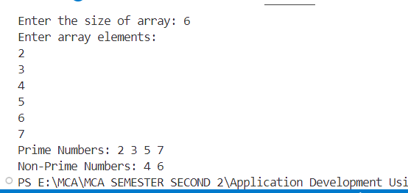

**Program 26: Write a program to implement the inheritance layout:**

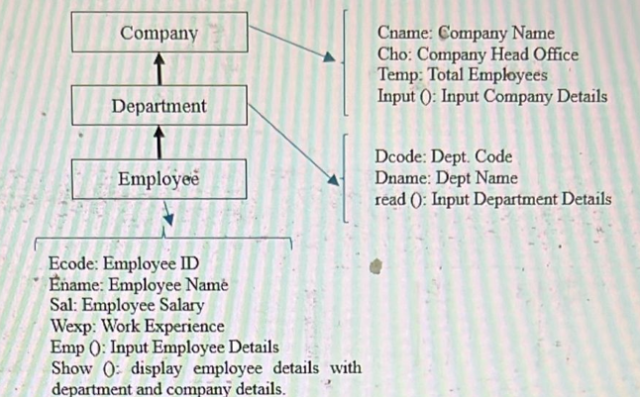

**Code:**

|  |
| --- |
| //Company.cs file  using System;  public class Company  {  public string Cname, Cho;  public int Temp;  public void Input()  {  Console.Write("Enter Company Name: ");  Cname = Console.ReadLine();  Console.Write("Enter Company Head Office: ");  Cho = Console.ReadLine();  Console.Write("Enter Total Employees: ");  Temp = Convert.ToInt32(Console.ReadLine());  }  }  public class Department : Company  {  public string Dcode, Dname;  public void Read()  {  Console.Write("Enter Department Code: ");  Dcode = Console.ReadLine();  Console.Write("Enter Department Name: ");  Dname = Console.ReadLine();  }  }  public class Employee : Department  {  public string Ecode, Ename;  public double Sal;  public int Wexp;  public void Emp()  {  Console.Write("Enter Employee ID: ");  Ecode = Console.ReadLine();  Console.Write("Enter Employee Name: ");  Ename = Console.ReadLine();  Console.Write("Enter Employee Salary: ");  Sal = Convert.ToDouble(Console.ReadLine());  Console.Write("Enter Work Experience (Years): ");  Wexp = Convert.ToInt32(Console.ReadLine());  }  public void Show()  {  Console.WriteLine("\n--- Employee Details ---");  Console.WriteLine($"Employee ID: {Ecode}");  Console.WriteLine($"Employee Name: {Ename}");  Console.WriteLine($"Salary: {Sal}");  Console.WriteLine($"Work Experience: {Wexp} years");  Console.WriteLine("\n--- Department Details ---");  Console.WriteLine($"Department Code: {Dcode}");  Console.WriteLine($"Department Name: {Dname}");  Console.WriteLine("\n--- Company Details ---");  Console.WriteLine($"Company Name: {Cname}");  Console.WriteLine($"Head Office: {Cho}");  Console.WriteLine($"Total Employees: {Temp}");  }  }  // Program.cs file  using System;  public class Program  {  public static void Main()  {  Employee emp = new Employee();  emp.Input();  emp.Read();  emp.Emp();  emp.Show();  }  } |

**Output:**

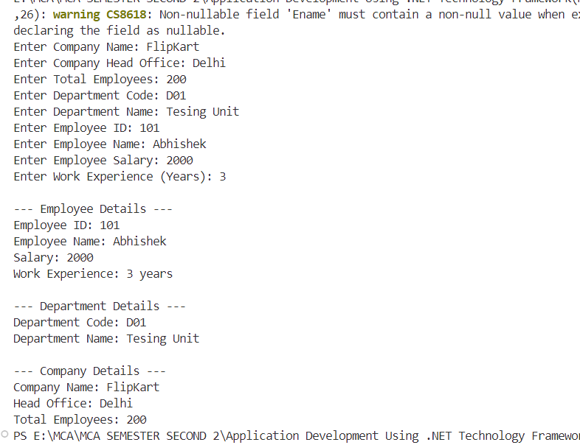

**Program 27: Write a program to take any string from user and count how many times "is" word occur in a string.**

**Code:**

|  |
| --- |
| using System;  public class Program  {  public static void Main()  {  Console.Write("Enter a string: ");  string str = Console.ReadLine();    int count = 0;  int i = 0;  while (i < str.Length - 1)  {  if ((i == 0 || str[i - 1] == ' ') && str[i] == 'i' && str[i + 1] == 's' && (i + 2 == str.Length || str[i + 2] == ' '))  {  count++;  }  i++;  }  Console.WriteLine("The word 'is' appears " + count + " times.");  }  } |

**Output:**

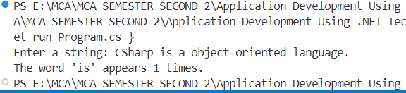

**Program 28: Write a program to take any string from user and count the occurrence of each character of a string.**

**Code:**

|  |
| --- |
| using System;  public class Program  {  public static void Main()  {  Console.Write("Enter a string: ");  string str = Console.ReadLine();    int[] freq = new int[256];  int i = 0;  while (i < str.Length)  {  int ascii = (int)str[i];  freq[ascii]++;  i++;  }  Console.WriteLine("Character occurrences:");  i = 0;  while (i < 256)  {  if (freq[i] > 0)  {  Console.WriteLine("'" + (char)i + "' appears " + freq[i] + " times");  }  i++;  }  }  } |

**Output:**

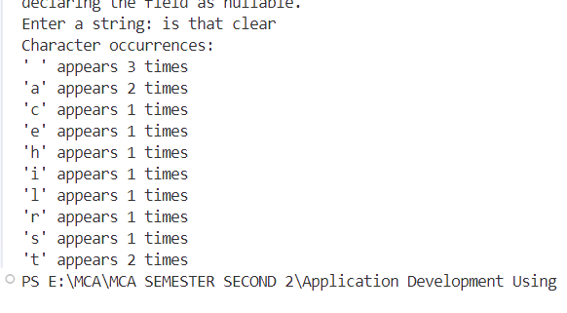

**Program 29: Write a program to take any string from user and count how many times one vowel comes after another.**

**Code:**

|  |
| --- |
| using System;  public class Program  {  public static void Main()  {  Console.Write("Enter a string: ");  string str = Console.ReadLine();    char[] vowels = { 'a', 'e', 'i', 'o', 'u', 'A', 'E', 'I', 'O', 'U' };  int count = 0;  int i = 0;  while (i < str.Length - 1)  {  bool firstVowel = false, secondVowel = false;  int j = 0;  while (j < vowels.Length)  {  if (str[i] == vowels[j])  firstVowel = true;  if (str[i + 1] == vowels[j])  secondVowel = true;  j++;  }  if (firstVowel && secondVowel)  count++;  i++;  }  Console.WriteLine("Number of times one vowel comes after another: " + count);  }  } |

**Output:**

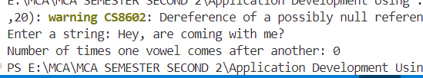

**Program 30: Write a program to take any string from user and divide into two arrays in such a way that all vowels store into separate array and consonant into another array. If the size of the first array is greater than second array, then print the actual string in lower case otherwise in upper case.**

**Code:**

|  |
| --- |
| using System;  public class Program  {  public static void Main()  {  Console.Write("Enter a string: ");  string str = Console.ReadLine();  char[] vowelsArray = new char[str.Length];  char[] consonantsArray = new char[str.Length];  char[] vowels = { 'a', 'e', 'i', 'o', 'u', 'A', 'E', 'I', 'O', 'U' };  int vIndex = 0, cIndex = 0;  int i = 0;  while (i < str.Length)  {  char ch = str[i];  bool isVowel = false;  int j = 0;  while (j < vowels.Length)  {  if (ch == vowels[j])  {  isVowel = true;  break;  }  j++;  }  if (isVowel)  vowelsArray[vIndex++] = ch;  else if ((ch >= 'a' && ch <= 'z') || (ch >= 'A' && ch <= 'Z'))  consonantsArray[cIndex++] = ch;  i++;  }  if (vIndex > cIndex)  Console.WriteLine(str.ToLower());  else  Console.WriteLine(str.ToUpper());  }  } |

**Output:**

